Capstone Project-1

“Customer Profiling for UK Online Retail Industry using K-Means Clustering and RFM Model”

In partial fulfillment of requirements for the degree of
Master of Science (MS) In Artificial Intelligence
Probability and Statistics for Artificial Intelligence (AAI-500-IN2)

Submitted by Group 9:
Ms. Nehpreet Kaur
Mr. Nikhil Bembi
Mr. Tamayi Mlanda


Under the Guidance of
Professor Azka Azka
University of San Diego

June 2025
Table of Contents

Project Overview 1
1. PROJECT OVERVIEW 1
1.1 PLATFORMS USED: 2
1.2 MOTIVATION: 3
1.3 OBJECTIVE: 3
1.4 ORGANIZATION OF THESIS: 3
Chapter 1: Introduction to the Dataset 5
Chapter 2: Data Cleaning and Preparation 6
A. Exploring the Dataset: 6
B. Checking for Missing Data in the Dataset 7
C. Key Observations: 9
Chapter 3: Exploratory Data Analysis (EDA) 12
Research Questions: 12
Descriptive Statistics and Exploratory Data Analysis 13
Chapter 4: Model Selection 21
Model 01: RFM: Recency, Frequency, and Monetary Value Segmentation 21
Model 02: K-Means Clustering 21
Model 03: Hierarchical Clustering 21
Chapter 5: Model Analysis 22
Model 01: RFM: Recency, Frequency, and Monetary Value Segmentation 22
Model 02: K-Means Clustering 34
Model 03: Hierarchical Clustering 44
Chapter 6: Conclusion and Recommendations 46
Appendix 1: Jupyter Notebook 47
Appendix 2: PowerPoint Presentation 48

Project Overview

PROJECT OVERVIEW
This project centers around a descriptive analysis of a UK-based Online Retail Dataset that captures real-world transactions from a giftware e-commerce business. With over 541,000 records, the dataset offers a detailed snapshot of customer purchases made through an invoice-based system.
By exploring this data, we hope to uncover meaningful insights into customer purchasing behavior, product popularity, and sales trends over time. Our goal is to identify patterns that can inform smarter business decisions—whether it's segmenting customers, spotting seasonal demand, or optimizing inventory. This analysis serves as the groundwork for more advanced exploration, potentially leading to predictive models and actionable strategies that add real value to the retail space.
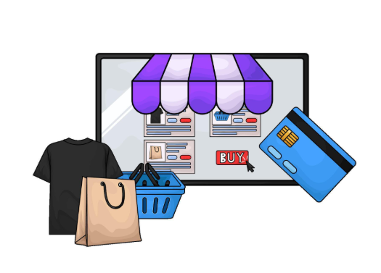
Figure 1.1: Online Retail Illustration

PLATFORMS USED:
- Google Colab-

Figure 1.1.1: Google Colab Logo
Google Colab is a free cloud-based platform provided by Google that enables users to develop Python code within an interactive notebook environment.
It’s widely used by data professionals, researchers, and students for various tasks including data analysis, machine learning, and creating visualizations. Because everything runs on Google’s cloud servers, there’s no need to set up anything on your computer. You also get access to powerful computing resources, including GPUs, which help speed up processing. Plus, sharing your work is easy — just like sharing a regular Google Doc — making teamwork and collaboration simple and seamless.
- Turnitin-

Figure 1.1.2: Turnitin Logo
Turnitin is a popular online tool that helps schools and universities make sure students’ work is original. It scans submitted papers by comparing them to a huge collection of academic articles, websites, and other materials to spot any copied content. By doing this, Turnitin supports honest work and encourages students to give proper credit to the sources they use.

MOTIVATION:
This dataset comprises over 540,000 transactions from a UK-based online gift retailer. By analyzing this data, we can uncover meaningful patterns in customer purchasing behavior and identify the most popular products. It also enables us to observe how sales fluctuate over time and vary across different regions. These insights can inform more strategic decisions regarding inventory management and marketing planning. Furthermore, gaining a deeper understanding of distinct customer segments allows for the creation of more personalized promotional campaigns. Overall, this analysis provides a solid foundation for future advanced studies, such as predictive modeling.

OBJECTIVE:
The objective of this project is:
- Explore and summarize the dataset to understand its structure, key features, and quality.
- Identify patterns and trends in customer purchasing behavior over time.

ORGANIZATION OF THESIS:
This report is divided into several sections to walk you through the entire analysis of the UK online gift store dataset:
- Introduction to the Dataset
We start by explaining the background and reasons behind this project, outlining what we aim to achieve, and giving a brief overview of the dataset.
- Data Cleaning and Preparation
Here, we describe how we cleaned the data—fixing missing information, removing duplicates, and making sure everything is ready for analysis.
- Exploratory Data Analysis (EDA)
In this part, we dive into the data using charts and summaries to spot interesting patterns and trends.
- Model Selection
We explain how we chose the right models to analyze the data and make predictions.
- Model Analysis
This section shows the results from our models and what they tell us about the data.
- Conclusion and Recommendations
Finally, we wrap up by summarizing what we found, how it can help the business, and what could be done next.
At the end, you’ll find an Appendix with all the code and output from the notebook we used, so you can see exactly how the analysis was done.

Chapter 1: Introduction to the Dataset

The Online Retail dataset, available through the UCI Machine Learning Repository, offers a detailed view into actual e-commerce activity. It's frequently used in data science, machine learning, and business analytics due to its rich and practical content.
Here are the key highlights:
- Period: Contains transaction data collected between December 2010 and December 2011.
- Source: Sourced from a UK-based online retailer that specializes in selling a variety of gift items.
- Data Size: Includes information from over half a million transactions.
- Key Data Fields: The dataset features several important attributes, such as:
Invoice Number | Product Description | Quantity Purchased | Date of Purchase
Price per Item | Customer ID | Country of Purchase
- Potential Use Cases:
  - Understanding customer purchase behavior
  - Identifying customer frequency patterns over time
  - Analyzing which products perform best
  - Segmenting customers into meaningful groups
  - Predicting future demand and improving inventory planning

Chapter 2: Data Cleaning and Preparation

Before diving into any in-depth analysis of the Online Retail dataset, it was important to clean and organize the data carefully. This ensures that the insights drawn are accurate and meaningful. The process involved several key steps:

Exploring the Dataset:
We started by inspecting the initial rows of the dataset to get a clear sense of its structure and contents. Following this, we reviewed the data types for each column and assessed the dataset for any missing or incomplete entries.
What we found:
- The dataset contains more than 540,000 records, spanning 8 different fields.
- Around one-quarter of the CustomerID values were missing, which is significant.
- Few data in Description column is also incomplete or missing.
Because CustomerID is essential for monitoring individual customer transactions and behavior, we chose not to impute missing CustomerID values. Filling in these gaps could lead to inaccuracies, so it was preferable to either exclude these records or treat them with caution during the analysis.
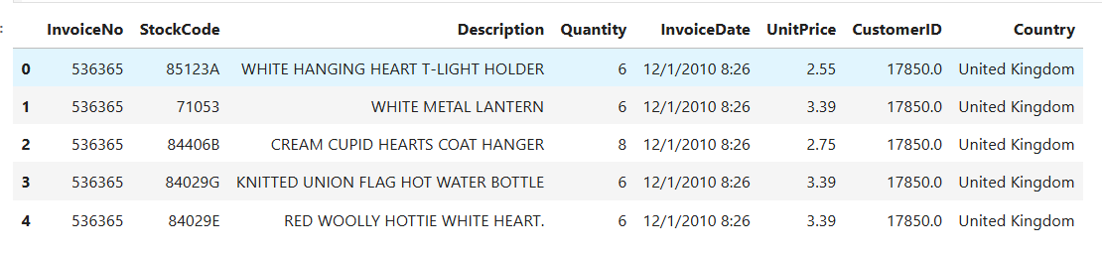
Figure 2.1.1: Preview of the Dataset

Checking for Missing Data in the Dataset
Before starting any detailed analysis, it’s important to identify any missing information in the dataset, as this can impact the accuracy of the results.

- Counting Missing Entries:
  - Using the command online_retail_df.isnull().sum(), we check missingness in the dataset.
  - The results show that most columns are complete, with missing values in:
    - 1,454 missing values in the Description column.
    - 135,080 missing values in the CustomerID column (25% of the data).
- Visualizing Missing Data Patterns:
  - The msno.matrix() function generates a nullity matrix.
  - This plot visualises the missing data and shows how it is distributed in the dataset and helps to improve our understanding of the missingness.
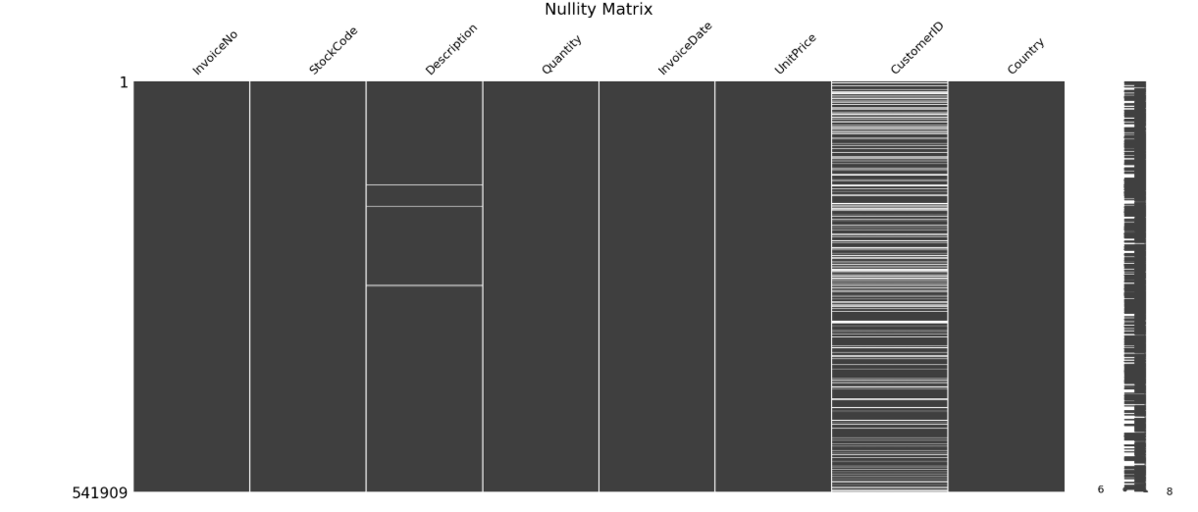
Figure 2.1.2: Nullity Matrix
- Calculating Missing Data Percentage:
  - The code works out the percentage of missing values for each column by taking the average of missing values and multiplying by 100.
  - A horizontal bar chart displays which columns have missing data and how much, making it easy to compare.
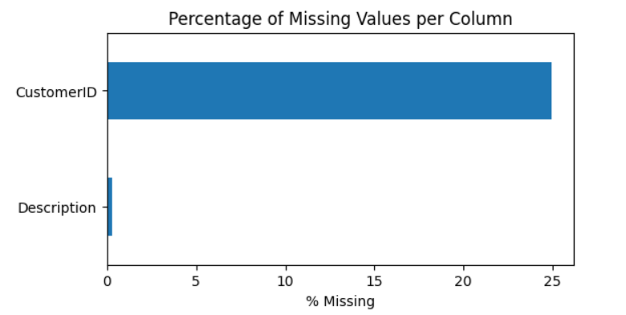
Figure 2.1.3: Missing Data Percentage

Key Observations:
After reviewing the initial rows, data types, and missing data, we observed that although the dataset is largely complete, several important adjustments are necessary. The InvoiceDate column requires conversion to a proper datetime format to enable time-based analyses. Additionally, the CustomerID column, currently stored as a float, should be handled as a categorical variable.
A significant concern is that approximately 25% of the CustomerID values are missing. Given that CustomerID is critical for customer-level analysis, imputing these missing values could compromise the accuracy of the results. As a result, we chose to exclude these entries from customer-focused analyses to maintain the validity and reliability of our findings.
Negative Values
- Negative Quantities:
Over 10,600 records had negative quantities, which likely represent returned products or cancelled orders. While valid from a transactional perspective, these were excluded from the main analysis focused on successful sales.
- Negative Prices:
Only two entries had negative unit prices, which could suggest input errors or refund adjustments. These were removed to maintain data integrity.
The dataset was then segmented into:
- Valid transactions, which include only positive quantities and non-cancelled entries.
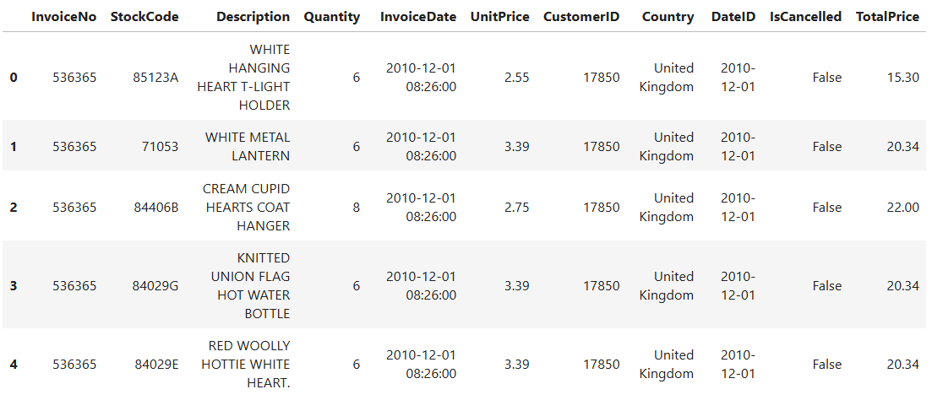
Figure 2.1.3: Valid transactions
- Cancellations/returns, retained for separate exploration of return behavior.
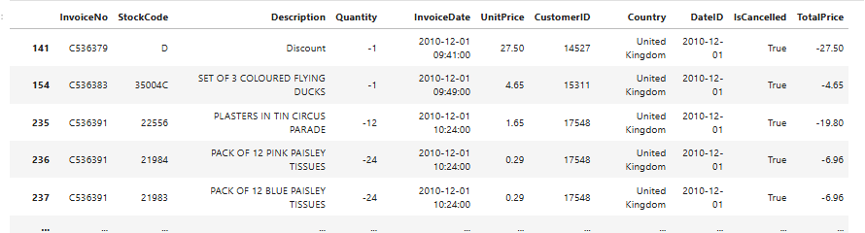Figure 2.1.4: Cancellations Identified in the data
Outlier Detection and Handling
During the data preparation phase, special attention was given to anomalies within the key numerical fields, namely Quantity and UnitPrice. These anomalies included outliers and negative values, which can potentially distort statistical analysis and customer segmentation results.
However, since the primary objective is to conduct customer segmentation using RFM-based clustering (K-Means and Hierarchical), we chose to retain outliers in the dataset. This decision ensures that the segmentation reflects the full spectrum of customer behavior, including high-volume or high-spending transactions, which are critical for identifying top-tier customers.
While outlier detection was conducted for diagnostic purposes and is documented in a subsequent section, we deliberately avoided removing these data points to maintain an unbiased representation of Recency, Frequency, and Monetary metrics. This approach enhances the integrity of the clustering process and supports more robust and inclusive customer profiling.
Outlier Mitigation Strategies
Retail data, especially sales volume (Quantity) and revenue (TotalPrice), often contains extreme values. These can result from high-volume purchases or data entry issues.
Several methods were considered to address such outliers:
- Filtering Cancellations and Returns:
All transactions marked as cancelled or involving negative quantities were excluded to focus the analysis on confirmed purchases.
- Winsorization:
This method involves capping values at predefined percentile limits (e.g., 1st and 99th), reducing the influence of outliers without removing data outright.
- IQR Filtering:
Using the Interquartile Range (IQR), values outside 1.5 times the IQR from the lower and upper quartiles were flagged as extreme and filtered accordingly.
- Quantile-Based Outlier Detection:
Ultimately, we implemented a quantile-based method that grouped records by CustomerID and StockCode and flagged any TotalPrice values falling outside the 5th–95th percentile range. This strategy enabled us to retain useful data while removing approximately 80,000 anomalous records from the core dataset.

Chapter 3: Exploratory Data Analysis (EDA)
By summarizing, visualizing, and identifying early trends, anomalies, or correlations, exploratory data analysis (EDA) aims to provide a thorough understanding of the dataset. Strategic decision-making, statistical modeling, and hypothesis formation are all based on EDA.
To guide our analysis effectively, we propose a set of research questions rooted in the variables provided in the dataset, such as
InvoiceNo, StockCode, Description, Quantity, InvoiceDate, UnitPrice, CustomerID, Country, along with derived features like TotalPrice and IsCancelled.

Research Questions:
These questions are designed to facilitate inferential analysis, which aims to derive insights about the broader customer base through statistical testing and predictive modeling.
- Understand Customer Behavior and Segmentation:
Do customers from different countries have significantly different purchasing patterns (e.g. average order value or frequency)?
Cross-national purchasing behavior can inform geo-targeted marketing strategies. A one-way ANOVA can be employed to assess whether the mean TotalPrice differs significantly across countries.
- Identify Trends in Sales Over Time:
Is there a significant seasonal effect on sales volume or transaction frequency?
Recognizing temporal patterns such as seasonality or periodic spikes in sales can support inventory and marketing planning. Time series analysis methods (e.g., decomposition or moving averages) can help detect these effects.
- Insights Into Customer Retention:
Do first-time customers have a significantly lower likelihood of repeat purchases compared to returning customers?
Analyzing retention patterns can support customer loyalty program design. Customers can be segmented into cohorts (first-time vs. repeat) based on CustomerID and purchase history. Predictive models such as logistic regression or survival analysis can estimate the probability of repeat purchases.

Descriptive Statistics and Exploratory Data Analysis
This EDA provides a detailed overview of the transaction data collected from the UK-based online retail business. The dataset covers the period 01-Dec-2010, to 09-Dec-2011, and includes more than 530,000 individual transactions.
Dataset Overview and Temporal Coverage
The dataset includes sales and return transactions, with timestamps ranging from:
From: 2010-12-01 08:26:00
To: 2011-12-09 12:50:00
This confirms that the dataset captures approximately one year of business activity.
            - Country Distribution
The majority of transactions originate from the United Kingdom, which aligns with the retailer's location. The top five countries by number of transaction are:
Country | Transactions
United Kingdom | 487,620
Germany | 9,042
France | 8,408
Ireland (EIRE) | 7,894
Spain | 2,485

These figures show the UK as the retailer's primary market and its reach across other European countries.
            - Summary Statistics for Numerical Features
The dataset contains two key numerical attributes: Quantity and UnitPrice. Below is a summary of each of these columns.
Metric | Quantity | UnitPrice
Count | 532,619 | 532,619
Mean | 10.24 | £3.89
Standard Deviation | 159.59 | £35.83
Minimum | -9,600 | £0.00
25th Percentile | 1.0 | £1.25
Median | 3.0 | £2.08
75th Percentile | 10.0 | £4.13
Maximum | 80,995 | £13,541.33
Interquartile Range (IQR) | 9.0 | £2.88

Negative quantities represent returns or cancelled transactions. Unit prices of zero may indicate promotional offers or potential data entry issues.
            - Distribution Analysis
To better understand the distributions and detect skewness and outliers, both histograms and boxplots were plotted for Quantity and UnitPrice.
Histogram Insights:
- Quantity: Displays a strong right skew, with a small subset of transactions involving large quantities.
- UnitPrice: Also exhibits a right-skewed distribution, with most prices clustered at the lower end and a few high-value items stretching the upper tail.
To reduce the impact of outliers, histograms were plotted within the 1st to 99th percentile ranges.
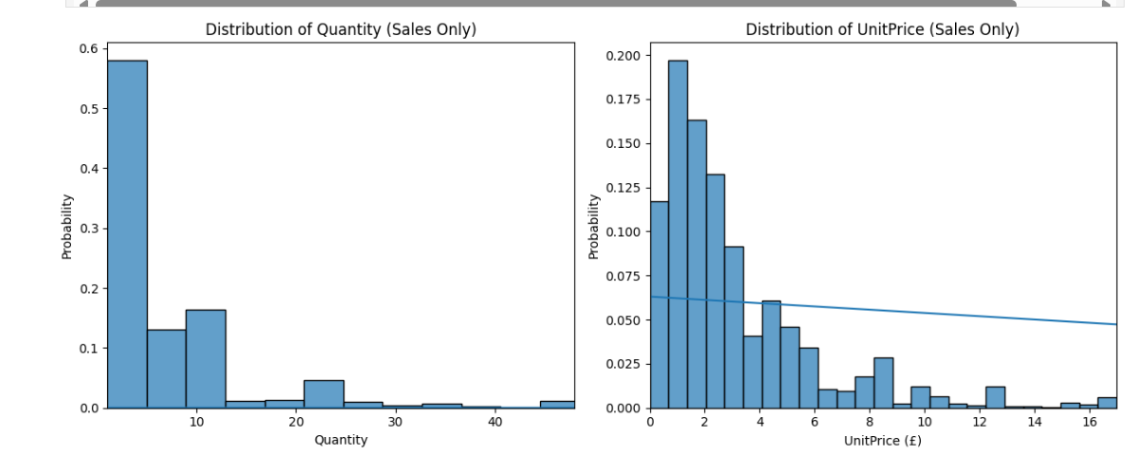
Figure 3.1: Distribution of Quantity and Unit Price
Boxplot Insights:
- Both variables include numerous outliers.
- Extreme values suggest a need for robust preprocessing in subsequent modeling (e.g., log transformation or outlier handling).
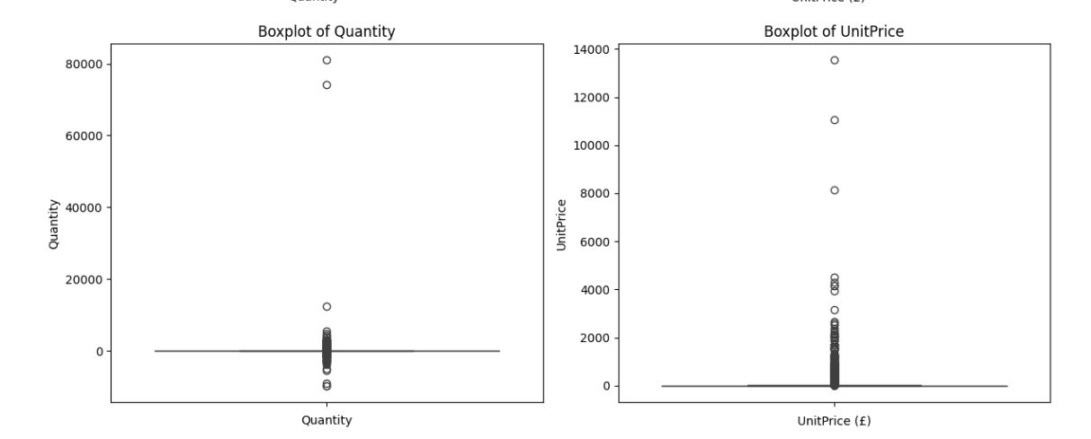
Figure 3.2: Boxplot of Quantity and Unit Price
            - Temporal Trends
To examine how transaction volume evolved, the number of transactions was aggregated monthly:
- A consistent pattern of sales is observed across months, with several spikes suggesting seasonal effects.
- Notable increases occur toward the end of the year, likely reflecting holiday season activity.
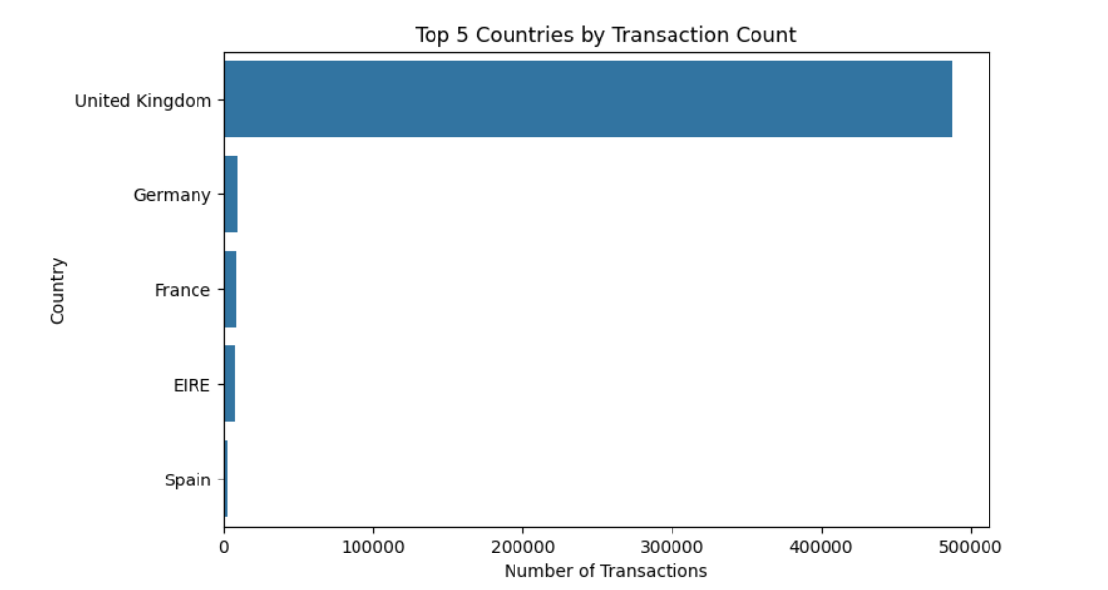
Figure 3.2: Top 5 Countries by Transaction Count
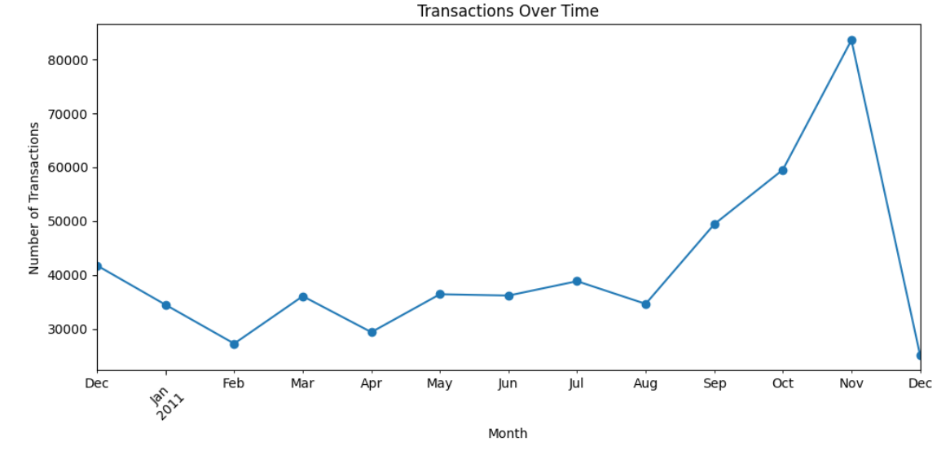
Figure 3.3: Top 5 Countries by Transaction Count
            - Daily Revenue Trend
This chart shows how much money the store made each day over time. It adds up the total revenue from all purchases made on each day. By looking at this chart, we can:
- See how earnings change from day to day
- Spot patterns, such as higher revenue during sales or holidays
- Identify slow periods where revenue drops
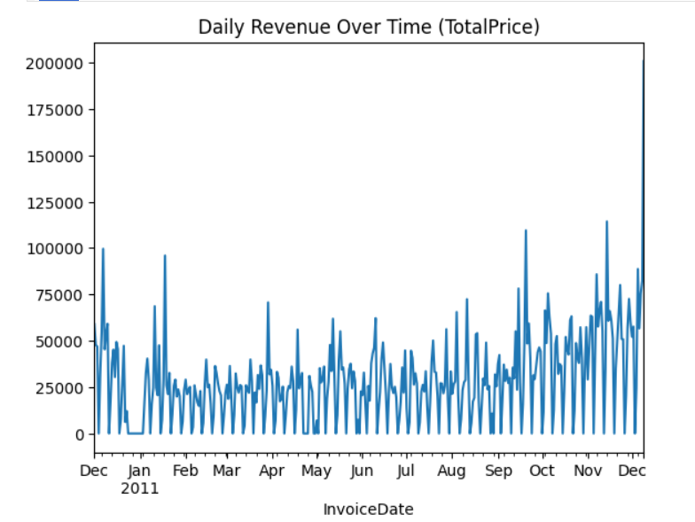
Figure 3.4: Daily Revenue Trend
            - Daily Sales Volume Trend
This chart displays the total number of items sold per day. It adds up how many units were purchased across all orders for each day. This helps us:
- Understand how daily sales change over time
- Find busy shopping days or times when fewer products were sold
- Detect regular patterns, such as weekly or seasonal trends
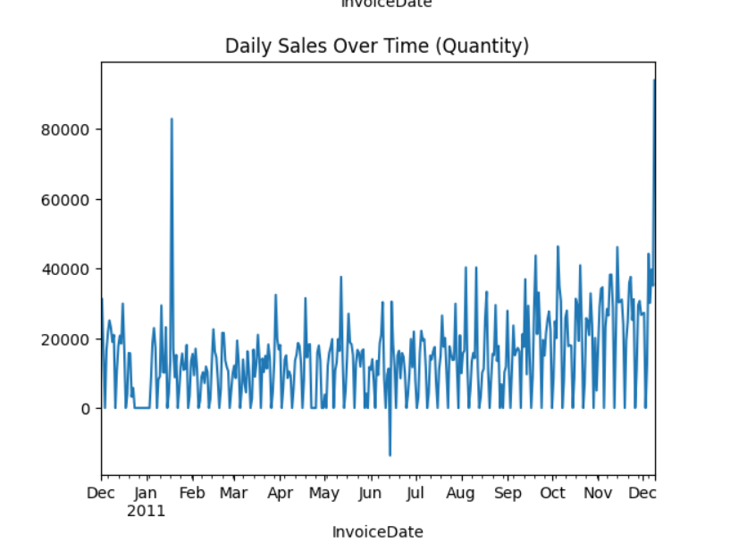
Figure 3.4: Daily Sales Volume Trend
Descriptive Statistics for Categorical Features
In addition to numerical attributes, the dataset includes several categorical variables that help describe the structure and diversity of the data. These include:
- Country: The geographic location of the customer
- StockCode: A unique identifier for each product
- CustomerID: An identifier for individual customers
- IsCancelled: A binary indicator for cancelled or returned transactions
- Unique Values Analysis
An initial exploration of the categorical columns revealed the following:
- Country contains 38 unique values, indicating that customers placed orders from 38 different countries.
- StockCode includes 4,059 distinct products, showing a wide variety in the inventory.
- CustomerID has 4,340 unique entries, reflecting the number of individual customers recorded.
- Cancellations (via IsCancelled) sum to 0, suggesting that the filtered dataset includes only completed (non-cancelled) transactions.
This information helps assess data granularity, diversity, and coverage of customer and product activity.
- Frequency Distribution Visualization
To gain further insight, bar charts were plotted to show the top 10 most frequent values in each categorical column:
- Top Countries: Identifies the nations with the highest number of transactions, emphasizing dominant markets such as the UK.
- Top StockCodes: Highlights the most frequently purchased products.
- Top CustomerIDs: Displays the customers with the most transactions, offering a view into repeat purchasing behavior.
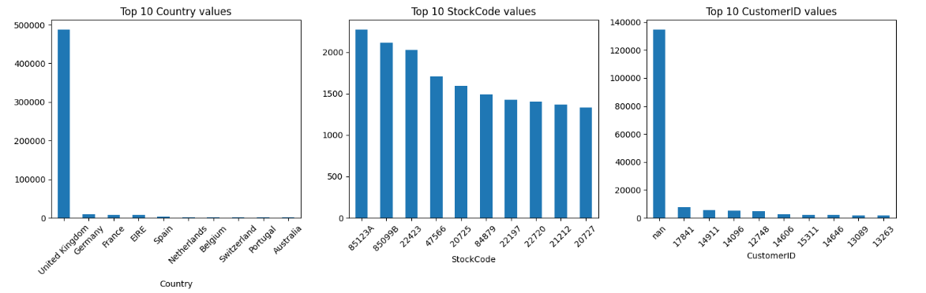
Figure 3.5: Descriptive histogram
These visual summaries are useful for detecting concentration patterns, such as heavy reliance on certain markets or products, and may help in targeted marketing or inventory optimization.

Chapter 4: Model Selection

Model 01: RFM: Recency, Frequency, and Monetary Value Segmentation
The online retail dataset was subjected to an RFM (Recency, Frequency, Monetary) analysis to enhance strategic decision-making in customer relationship management and gain a deeper understanding of customer behavior. Based on past transaction data, this method is a tried-and-true unsupervised technique for customer segmentation. It is especially helpful for identifying high-value consumers and adjusting marketing campaigns appropriately.

Model 02: K-Means Clustering
We used K-Means clustering to the RFM (Recency, Frequency, Monetary) features in order to segment the customer base by their purchase patterns. K-Means is an unsupervised machine learning technique that creates predetermined clusters from related data points. In order to reduce the distance within clusters, Kmeans iteratively updates the izcluster centroids after initializing them and assigning each transaction to its closest cluster centroid.
This approach is especially effective for customer segmentation as it enables companies to distinguish unique customer groups based on their behavior, helping to tailor marketing efforts, improve retention, and optimize resource distribution.

Model 03: Hierarchical Clustering
Hierarchical clustering aims to create a hierarchy of clusters. It is frequently used in bioinformatics, pattern recognition, and data mining to cluster related items according to their characteristics.

Chapter 5: Model Analysis

Model 01: RFM: Recency, Frequency, and Monetary Value Segmentation
To enhance the understanding of customer behavior and inform strategic decisions in customer relationship management, an RFM (Recency, Frequency, Monetary) analysis was applied to an online retail dataset. This well-known unsupervised technique categorizes customers based on their purchasing history and is particularly effective in identifying high-value customers and developing targeted marketing campaigns
  - Rationale for RFM Segmentation
The RFM model evaluates customer involvement based on three key factors:
- Recency (R): Refers to the time elapsed since a customer's most recent purchase. Customers with more recent purchases are generally seen as more actively engaged.
- Frequency (F): Reflects how often a customer buys within a specific period. Those who purchase more frequently are usually viewed as loyal and repeat buyers.
- Monetary (M): Represents the total spend by a customer. Customers with higher spending levels are considered more valuable due to their greater financial contribution.
This model is particularly suitable for the dataset at hand as it provides meaningful customer insights without requiring predictive modeling techniques or labeled training data. It enables segmentation based on observable transactional behavior alone.
  - Data Preparation for RFM Analysis
To guarantee the accuracy and dependability of the RFM analysis, several data preprocessing steps were carried out beforehand.
- Exclusion of cancelled transactions: Invoices that begin with the letter 'C' were removed, as these represent cancellations or returns.

- CustomerID filtering: Only transactions with a valid (non-null) CustomerID were retained. Since customer-level segmentation is central to RFM, missing values in this field cannot be imputed.
- Removal of invalid records: Records with negative values in either Quantity or UnitPrice—aside from recognized discounts—were removed to avoid skewing the spending analysis.
- Feature Engineering (Total Price): A new variable was generated to determine the total spend on each transaction as the product of Quantity and UnitPrice. This is used as the RFM model’s Monetary value feature.

  - RFM Metric Calculation
The features are defined as follows:
- Recency measured the number of days since the customer's last purchase, relative to the last transaction in the dataset.
- Frequency represented each customer’s total number of purchase events.
- Monetary value was calculated as the total spend by each customer across all valid transactions.
- Valid transactions are understood to be successful purchases without returns.

  - Scoring Methodology
To enable standardized comparisons across customers, each RFM component was assigned a quartile-based score ranging from 1 to 4, where:
- A score of 4 represents the most favorable behavior (e.g., most recent purchase, highest frequency, or highest spending).
- A score of 1 represents the least favorable segment for that metric.
This quantile-based binning allows for a simple yet interpretable ranking system, facilitating downstream segmentation and cluster analysis. The final RFM scores can also be combined to form composite customer profiles (e.g., “444” indicating top-tier customers in all three categories).
5. Use Case and Strategic Implications
RFM segmentation enables businesses to:
- Identify loyal and high-value customers for retention strategies
- Spot inactive or low-engagement customers for reactivation campaigns
- Design personalized promotions based on customer profiles
- Allocate marketing budgets more efficiently by focusing on high-return segments
Overall, the RFM analysis serves as a robust, data-driven foundation for customer-centric strategies and supports deeper behavioral modeling in future work.
PLOT 1: DISTRIBUTION OF RFM SCORES
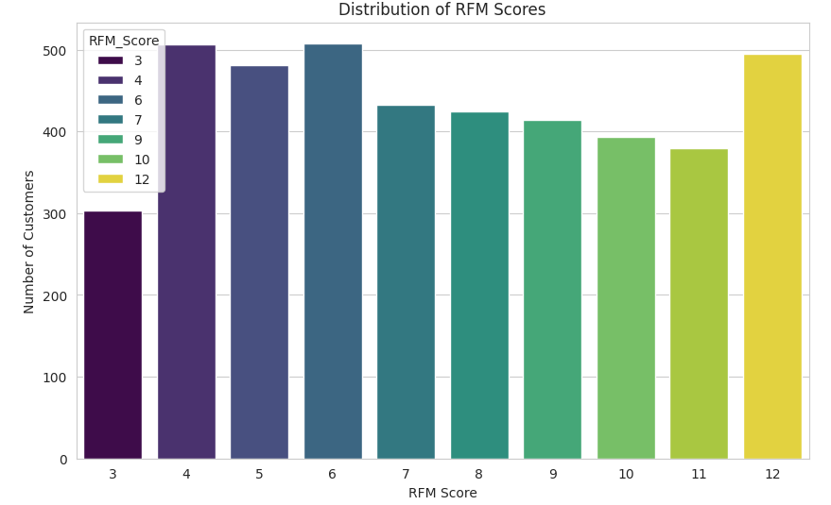
Figure 3.6: Distribution of RFM Scores
RFM Score Distribution Analysis
- Distribution Summary
The RFM score distribution reveals a non-uniform and bimodal pattern, with customer counts ranging from approximately 100 to 500 per score. Peaks are observed at scores 5 and 12, suggesting two dominant behavioral clusters.
- Analytical Trends
- Score 12 (~500 customers): Indicates customers with optimal recency, frequency, and monetary values—representing the highest engagement tier.
- Score 5 (~500 customers): Reflects a sizable segment with moderate engagement, likely strong in one or two RFM dimensions.
- Scores 3–4 (100–450 customers): Correspond to low-engagement segments, with infrequent, low-value, or older purchases.
- Scores 6–11: Display a progressive decline, implying a drop in sustained high performance, followed by a sharp recovery at score 12.
- Strategic Implications
- Top-tier (RFM 12): The high-value customer segment is ideal for retention-focused strategies, including loyalty programs, personalized promotions, and predictive models for customer lifetime value..
- Mid-tier (RFM 5): Ideal for conversion-focused campaigns, including cross-sell and upsell efforts to elevate them to premium tiers.
- Low-tier (RFM 3–4): Require reactivation tactics such as targeted promotions or re-engagement workflows to mitigate churn.
- Declining Middle (RFM 6–11): Represents a leakage zone, where customers may be slipping from high to mid engagement—warranting early intervention.

PLOT 2: RECENCY VS. MONETARY SCATTER
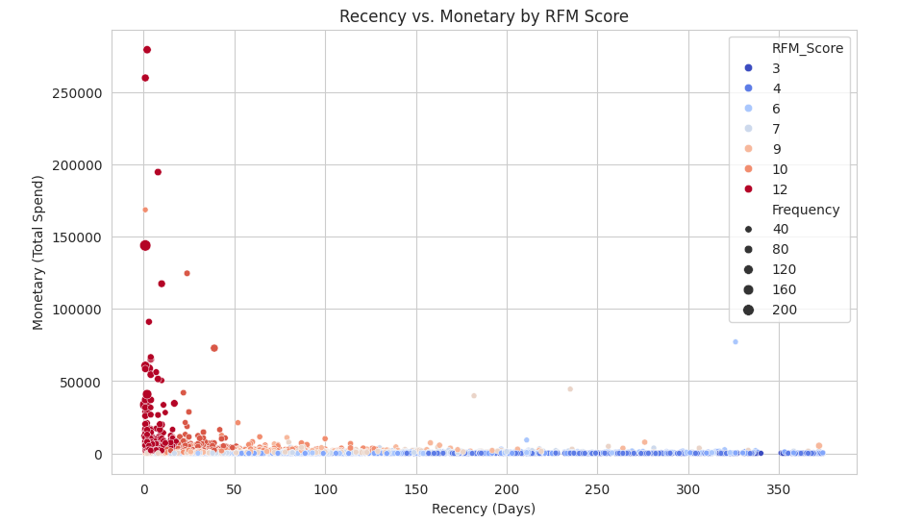
Figure 3.7: Recency vs. Monetary Scatter by RFM Score
The scatter plot visualizes customer behavior using two primary RFM dimensions: Recency (days since last purchase, x-axis) and Monetary value (total spend in GBP, y-axis). Color encodes RFM scores, while point size represents Frequency (number of transactions). This multidimensional view enables a nuanced understanding of customer segments.
Key Observations
  - Recency Distribution
- A significant cluster of customers made purchases within the last 100 days, suggesting strong recent engagement.
- A smaller subset shows recency values between 300–350 days, indicating a segment nearing inactivity or churn risk.
  - Monetary Value Distribution
- Total customer spend varies widely, with the y-axis extending up to £250,000.
- Most customers spend under £50,000, concentrated in the lower y-axis range.
- A few high-value outliers exceed £150,000, representing key contributors to revenue.
  - RFM Score Segmentation
- Low RFM Scores (3–7, blue tones): These customers tend to have high recency (i.e., older purchases) and low monetary values, indicating disengagement.
- Moderate RFM Scores (9–10, orange): Positioned in the mid-range of both spend and recency, this group is active but not yet high-value.
- High RFM Score (12, red): These customers are both recent and high-spending, with monetary values often exceeding £50,000. There are few but critically important.
  - Frequency Correlation
- Point size reflects transaction count; larger points (high frequency) appear more often in high RFM segments, especially at high spend levels.
- Smaller points dominate lower RFM scores, reinforcing the link between low frequency and lower customer value.
Strategic Business Insights
- High-Value Segment (RFM = 12): Small but highly profitable group; ideal for VIP loyalty programs, exclusive offers, and retention-focused strategies.
- At-Risk Customers (RFM 3–7): Characterized by long inactivity and low spend; require re-engagement campaigns, such as personalized discounts or reminders.
- Growth Segment (RFM 9–10): Mid-tier customers with upward potential; targeted upselling or purchase incentives could push them into the top tier.
- Frequency as a Lever: A clear correlation exists between frequency and monetary value; driving repeat purchases could significantly increase overall customer value.

PLOT 3: TOP 10 CUSTOMERS BY MONETARY VALUE
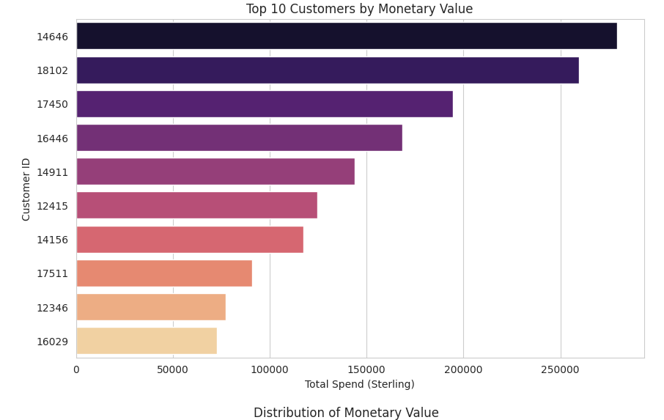
Figure 3.7: Top 10 Customers by Monetary Value
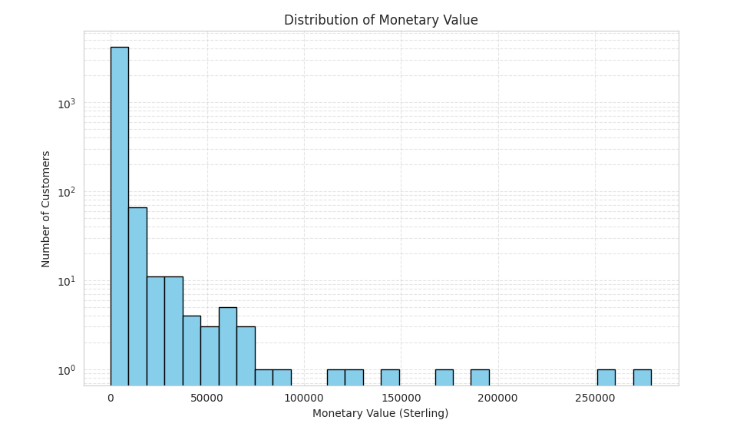
Figure 3.8: Distribution of Monetary Value

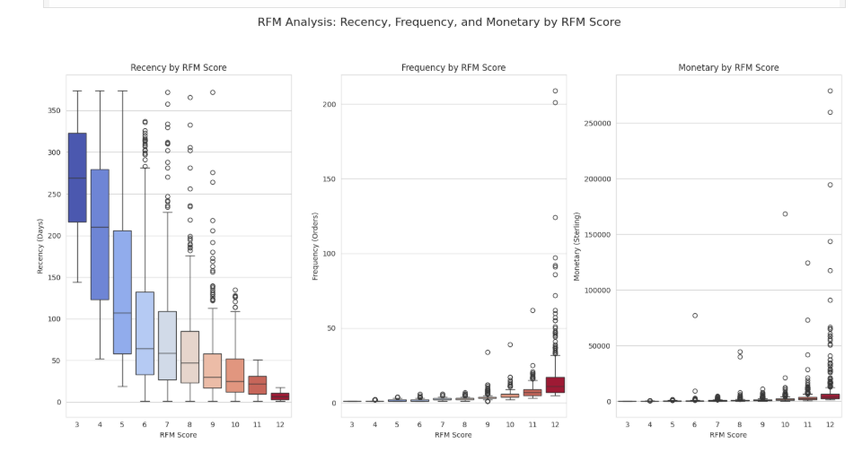
Figure 3.9: Recency, Frequency, and Monetary by RFM Score
This visualization displays the geographic distribution of customers within top RFM segments (e.g., ‘444’, ‘433’) by country. It helps identify whether high-value customers are concentrated in specific regions—such as the UK, which is the primary market, or in international markets.
By mapping customer value across geographies, businesses can:
- Detect regional concentration of premium customers
- Assess international market potential
- Tailor regional marketing efforts toward high-performing customer segments
Given that exploratory analysis shows a majority of transactions originate in the UK, this visualization is key to uncovering untapped value in other countries.
Distribution Overview
The histogram of customer monetary values shows a strong right-skew, where most customers spend less than £50,000. A long tail stretches toward £250,000, highlighting a few high-spending outliers. Using a logarithmic scale helps to better visualize the dense cluster of lower spenders while still displaying rare, high-value customers.

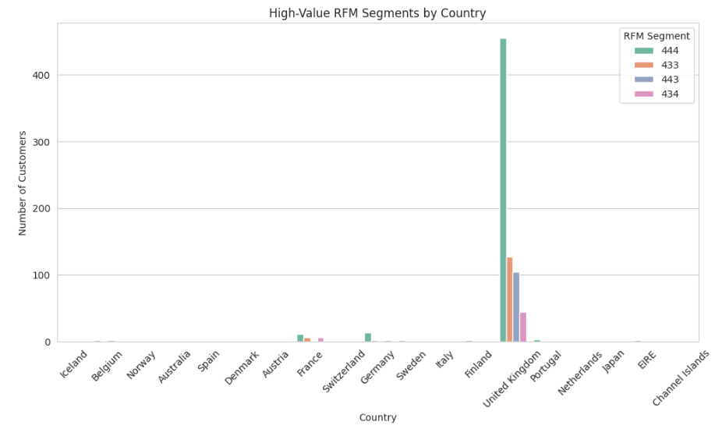
Figure 3.10: High-Value RFM Segments by Country
A time series analysis of transaction counts for top RFM customers (e.g., score ‘444’) reveals temporal purchasing patterns. This helps identify seasonal spikes, such as increased activity during holiday periods or end-of-year sales, which are critical for marketing calendar planning. Given the dataset covers the period from December 2010 to December 2011, this analysis provides insights into key revenue-generating time frames for high-value customer segments.
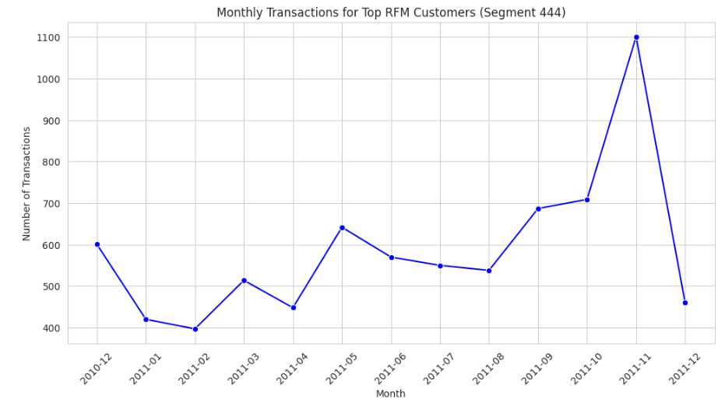
Figure 3.11: Monthly Transactions for Top RFM Customers
The time series shows that top RFM customers shop more often in November and December, likely due to holiday shopping around Christmas. There is also increased activity around Easter.
These patterns suggest that the best time to run big sales or targeted promotions is during these key holiday periods, especially late in the year.
Heatmap of RFM Score Combinations
Below is a heatmap of customer counts across combinations of R, F, and M scores to show which combinations are most common. This provides a compact view of how Recency, Frequency, and Monetary scores interact, highlighting dominant customer profiles.
The heatmap is essentially a pivot table where the x-axis represents Frequency (F) scores, the y-axis represents Recency (R) scores, and the color intensity (with annotations) indicates the number of customers in each R-F combination. This visualization helps identify the most common customer profiles based on their RFM scores.
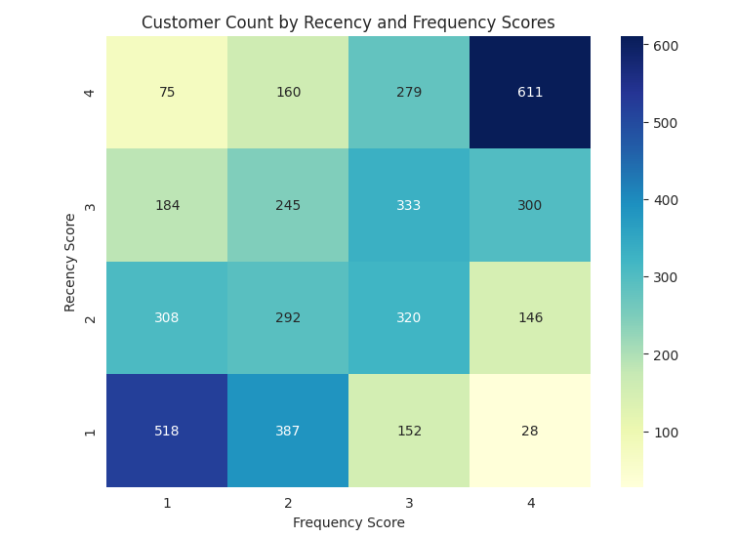
Figure 3.11: Customer Count by Recency and Frequency Scores
- Dominant Profile: The heatmap shows 611 customers with R=4 and F=4, indicating strong recent and frequent activity, aligning with top spenders like Customer 14646.
- At-Risk Segment: A notable 1-1 or 1-2 area suggests churn risk. With 518 customers in the 1-1 segment, re-engagement strategies are needed for those inactive since late 2010.
- Growth Opportunity: A 4-1 (75 customers) or 4-2 (160 customers) clusters indicate new customers. Offering discounts could boost their frequency.
Business action: Focus retention on 4-4/4-3, re-engagement on 1-1, and growth on 4-1
Key Business Insights
  - Top Spenders
- Customers 14646 and 18102 alone contribute over £400,000, making them the most valuable.
- These customers should be targeted with personalized retention strategies, such as exclusive offers or loyalty rewards.
  - High-Potential Clients
- Customers 17450, 16446, and 14911 (spending £100,000–£175,000) form a strong mid-tier group.
- Encouraging repeat purchases or increasing order value could move them to the top segment.
  - Growth Segment
- Customers like 14156, 17511, 12346, and 16029 (spending £25,000–£75,000) are in the top 10 but have room to grow.
- These are ideal for upselling or cross-selling strategies.
  - Revenue Concentration
- A large share of total revenue comes from a small group of top customers.
- Focusing on this group can improve ROI, but over-dependence should be managed with diversified engagement.
  - Segmentation Opportunity
- The sharp drop after £50,000 highlights a segment of mid-range spenders.
- Targeting this group with loyalty programs could increase their value and fill the gap between low and high spenders.

Model 02: K-Means Clustering
This method is particularly suitable for customer segmentation because it allows businesses to identify distinct customer groups based on behavior, which can guide targeted marketing, retention strategies, and resource allocation.
Scaling RFM Features
Prior to performing clustering, the RFM variables were standardized using z-score normalization through the StandardScaler method. As Recency, Frequency, and Monetary values vary in scale and units, normalization was essential to prevent any one feature from disproportionately influencing the clustering outcome. This process adjusted each feature to have a mean of 0 and a standard deviation of 1.
Clustering Approach
Two clustering techniques were explored:
- K-Means Clustering: Used the scaled RFM features to assign customers into k groups based on behavioral similarity.
- Hierarchical Clustering (Ward's Linkage): Built a dendrogram to visually explore the cluster hierarchy. This helps in understanding natural divisions in the data without predefining the number of clusters.

Determining Optimal Number of Clusters
To identify the most appropriate number of clusters (k) for K-Means, we used two evaluation metrics:
- Silhouette Score: Indicates how well a point fits within its cluster. Values range from -1 to +1, with higher values meaning better cohesion and separation.
- Calinski-Harabasz Index: Measures the ratio of between-cluster dispersion to within-cluster dispersion. A higher score indicates well-separated and compact clusters.
These metrics are calculated for k values ranging from 2 to 9, and the results are plotted to visually assess the best cluster number.
For k-Means, to determine the most suitable number of clusters, we tested several values of k within the range of 2 to 9. For each value, it applies K-Means clustering to the scaled RFM data and calculates two key metrics: the Silhouette Score, which reflects how well each customer matches with its assigned cluster (higher values suggest better cohesion), and the Calinski-Harabasz Index, which measures how distinct and well-separated the clusters are. These scores are then visualized through plots, allowing easy comparison across different k values. The function identifies the optimal number of clusters as the one with the highest Silhouette Score, ensuring the clustering structure is both meaningful and reliable.
Clustering and Optimal k Selection
When using clustering methods like K-Means or Hierarchical Clustering, selecting the optimal number of clusters (k) requires assessing how effectively the data is grouped at different k values. In this study, we evaluate cluster counts from 2 to 9 by applying two metrics to gauge cluster quality:
- Silhouette Score: Indicates how closely each data point matches its own cluster compared to others, with values ranging from -1 to 1; higher scores signify better clustering.
- Calinski-Harabasz Score: Represents the ratio of separation between clusters to the compactness within clusters; there is no upper limit, and higher values indicate superior clustering.
The process involves:
- Running K-Means for each k from 2 to 9.
- Calculating Silhouette and Calinski-Harabasz scores for each k.
- Selecting the k that optimizes one or both metrics—usually by identifying the highest score or a “knee” point where further increases in k offer limited improvement.
In this study, we selected the Silhouette Score to determine the optimal k due to its interpretability and reliability. Since it is bounded between -1 and 1, it is easier to interpret and compare across datasets (e.g., scores above 0.5 indicate good clustering, while scores below 0.2 suggest poor clustering). The Silhouette Score is also robust, as it considers both intra-cluster cohesion (how compact each cluster is) and inter-cluster separation (how distinct clusters are), making it a balanced metric. Additionally, it is sensitive to the clustering quality of individual points.
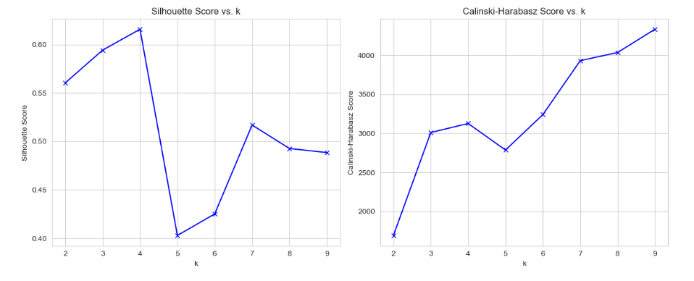
Figure 3.12: Elbow charts for Silhouette Score and Calinski-Harabasz Index
Business Context
In the context of RFM (Recency, Frequency, Monetary) analysis, selecting the right number of clusters is essential for producing actionable customer segments:
- Too few clusters (e.g., k = 2) may group high-value and loyal customers together, missing important distinctions for targeted marketing.
- Too many clusters (e.g., k = 8) might split similar customers unnecessarily, complicating strategic decisions.
- An optimal number of clusters (e.g., k = 4) typically yields meaningful segments such as High-Value, Loyal, At-Risk, and Emerging customers. These can support specific business actions like loyalty programs or re-engagement campaigns.
Applying K-Means
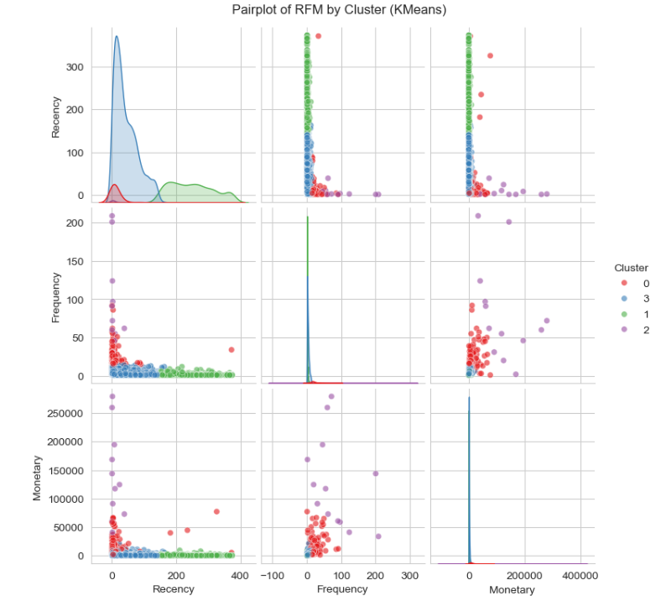
Figure 3.13: Pairplot of RFM by K-Means
Insight:
The Recency vs. Monetary scatter shows Cluster 0 tightly clustered at low Recency and high Monetary, which confirms a distinct High-Value segment.
Cluster 1 (At-Risk) has high Recency and low Frequency, target these customers with re-engagement campaign.
Cluster Profile Bar Plot (Plotly)
Description: Bar plot comparing mean Recency, Frequency, and Monetary across clusters, with bars grouped by cluster. Significance: Highlights average RFM values per cluster, making it easy to compare segment characteristics. It shows which metrics define each cluster (e.g., high Monetary for Cluster 0).
Clustering Choice: Distinct bar heights (e.g., Cluster 0: low Recency, high Monetary vs. Cluster 2: high Recency, low Monetary) indicate good clustering.
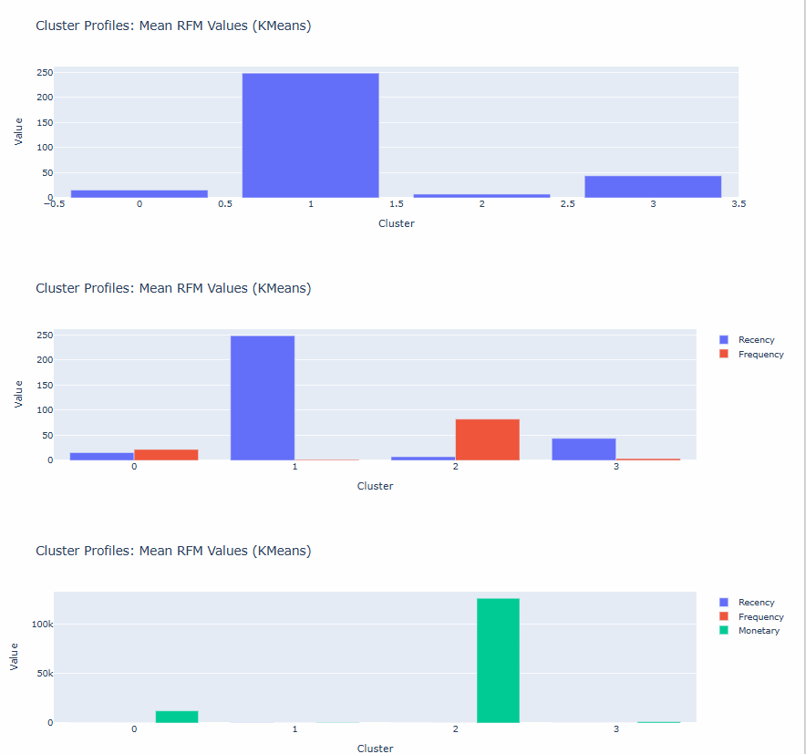
Figure 3.14: Cluster Profiles
Insight: High-Value customers ie Cluster 0 and Cluster 2 need loyalty programs (e.g., VIP discounts in France), while At-Risk customers (Cluster 1) need re-engagement (e.g., €5 vouchers in Germany).

Box Plots
Description: Three box plots (one for each RFM metric) shows median, quartiles, and outliers per cluster.
It displays the spread and variability of RFM metrics within each cluster. It helps us identify outliers (e.g., a customer in Cluster 2 with unusually high Monetary). Various median differences across clusters are also highlighted.
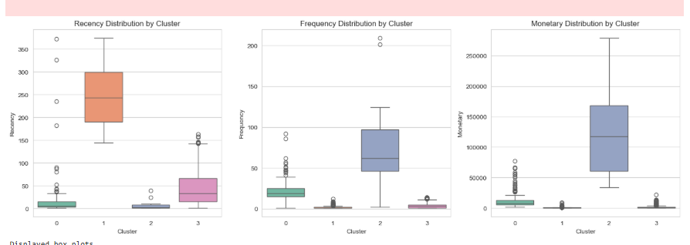
Figure 3.15: Box Plots for RFM by K-Means
Insight:
Clusters with wide Monetary spread (e.g., Cluster 2) may include diverse Loyal customers, suggesting targeted upsell campaigns (e.g., bundle offers in Germany)
Heatmap of Standardized Centroids
Description: Heatmap of standardized (z-scored) RFM means per cluster, with color intensity (red for positive, blue for negative) and annotations.It shows relative differences in RFM metrics across clusters on a standardized scale. It also highlights defining traits (e.g., negative Recency, positive Monetary for High-Value).
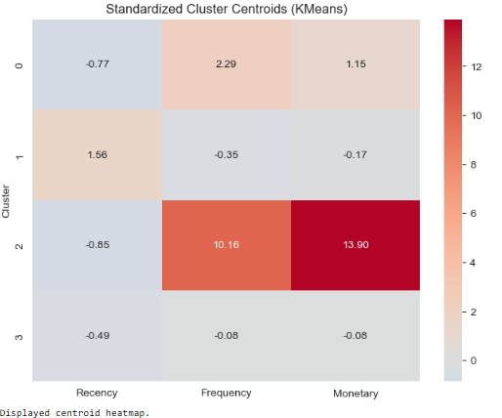
Figure 3.16: Heatmap for RFM by K-Means
Insight:
Cluster 0’s strong positive Monetary z-score suggests high-spending customers, ideal for premium offers (e.g., exclusive products in France).
2D Scatter Plots:
Description: Three interactive scatter plots showing pairs of RFM metrics, colored by cluster, with hover data (CustomerID).
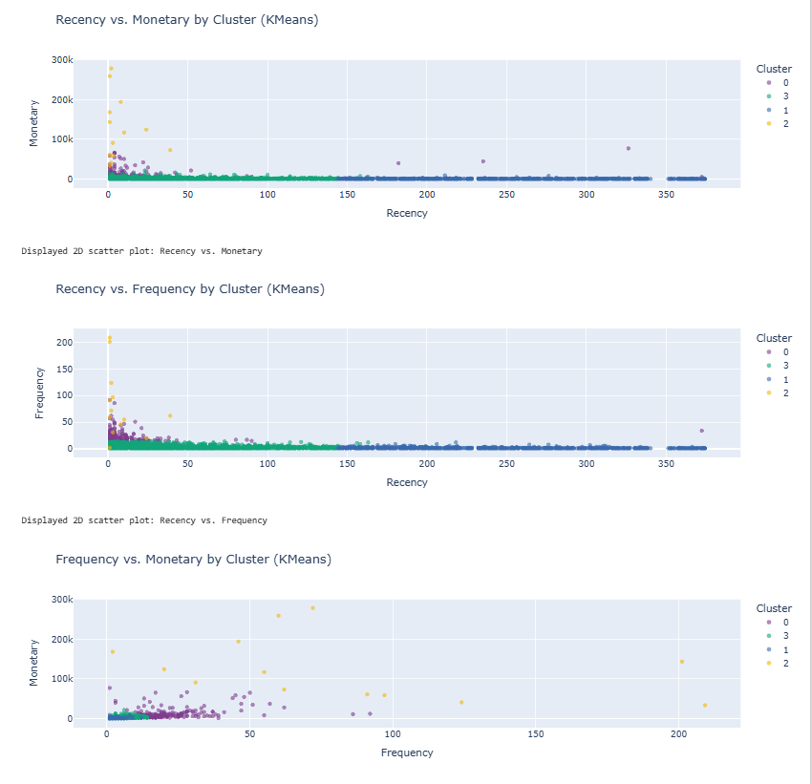
Figure 3.17: Scatterplot for RFM by K-Means
Insight:
Clear separation in Recency vs. Monetary (e.g., Cluster 1 at high Recency, low Monetary) supports re-engagement campaigns for At-Risk customers (e.g., Cluster 1).
Violin Plots
Description: Three violin plots showing the density and distribution of Recency, Frequency, and Monetary per cluster.
Combines box plot (median, quartiles) and KDE to show distribution shape and density.
Highlights multimodal distributions or skewness (e.g., Monetary in Cluster 3 may be skewed).
Reveals variability and density differences across clusters.
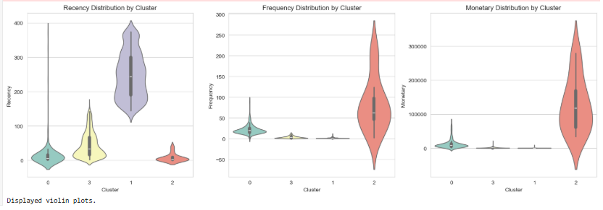
Figure 3.18: Violin Plots for RFM by K-Means
Insight:
Wide violins in Cluster 2 (Loyal) indicate varied spending, making them ideal for personalized upsell offers (e.g., Germany).
K-Means Cluster Summary
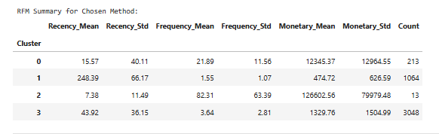

Model 03: Hierarchical Clustering
In cluster analysis, the hierarchical clustering technique that aims to create a nested structure of clusters. It is commonly applied in data mining, pattern recognition, and bioinformatics.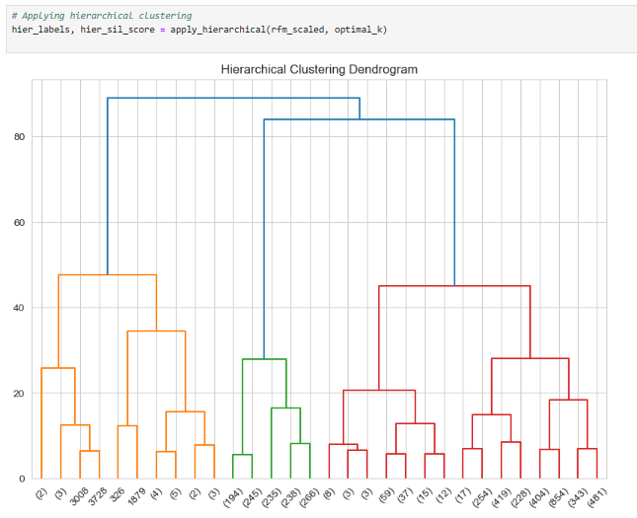
Figure 3.19: Hierarchical clustering Dendrogram
Hierarchical Clustering Summary:
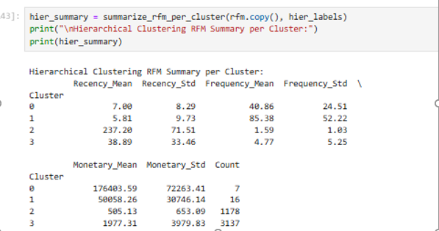
Comparing the performance of K-Means and Hierarchical Clustering
We compare the clustering performance of K-Means and Hierarchical Clustering using their Silhouette Scores, a metric that measures cluster cohesion and separation. It prints out which algorithm performed better based on the scores and provides a recommendation:
- K-Means is preferred if it yields a higher score due to its simplicity and scalability.
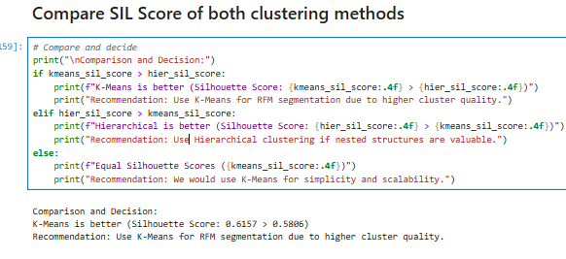
Insight: K-Means is better (Silhouette Score: 0.6157 > 0.5806)
Recommendation: Use K-Means for RFM segmentation due to higher cluster quality

Chapter 6: Conclusion and Recommendations
Final Insights:
- High-Value (e.g., Cluster 0): Bar plot/heatmap show low Recency, high Monetary → Offer VIP discounts (e.g., France).
- At-Risk (e.g., Cluster 1): High Recency in scatters/box plots → Re-engagement emails (e.g., €5 vouchers in Norway).
- Loyal (e.g., Cluster 2): Moderate RFM in bar plot, wide violin plots → Upsell bundles (e.g., Germany).
- Emerging (e.g., Cluster 3): Moderate bars | Box plots in → Onboarding offers (e.g., free shipping).

Appendix 1: Jupyter Notebook

Appendix 2: PowerPoint Presentation

